Mongodb Assignments

1.Get all documents

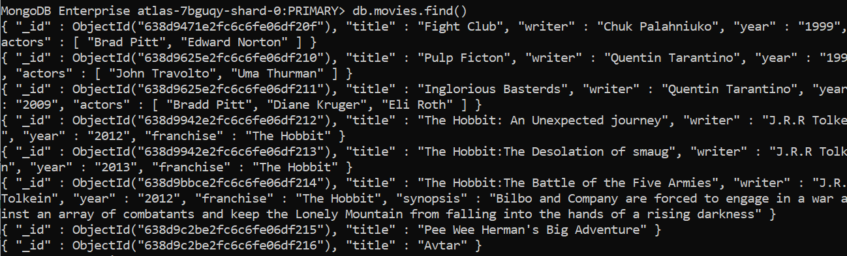

2.Get all documents with writer set to “Quentin Tarantino”

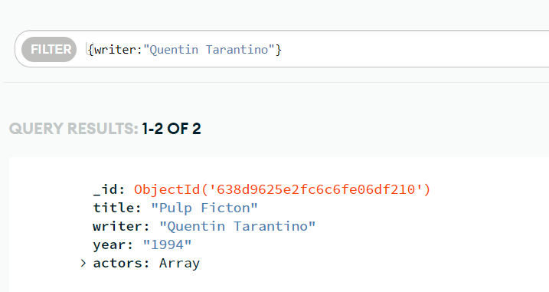

3.Get all documents where actors include actors “Brad Pitt”

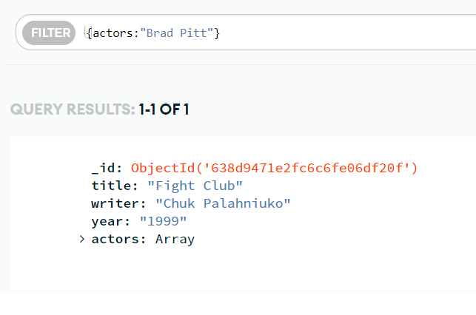

4.get all documents with franchise set to “The Hobbit”

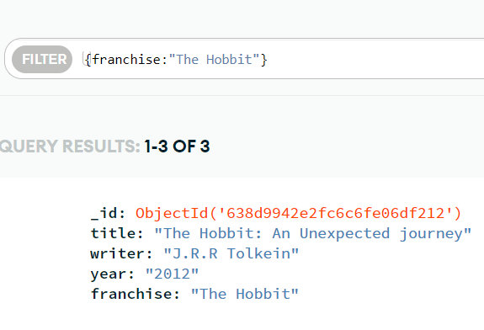

5.Get all movies released before in the 90s

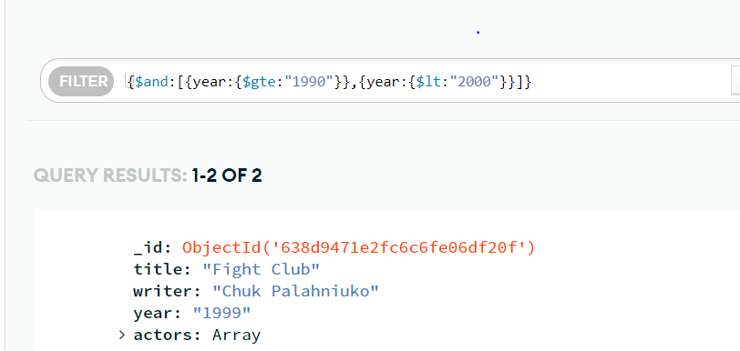

6.Get all the movies released before the year 2000 or after the 2010

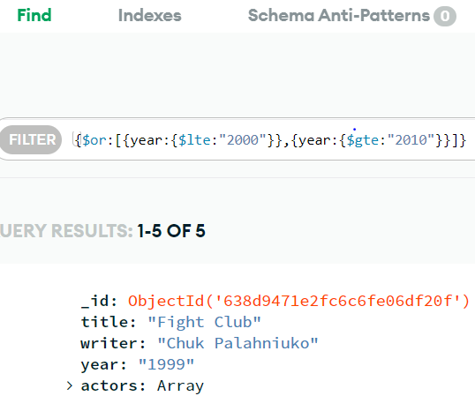

UPDATE DOCUMENTS

1.ADD synopsis to “The hobbit: An Unexpected journey”:

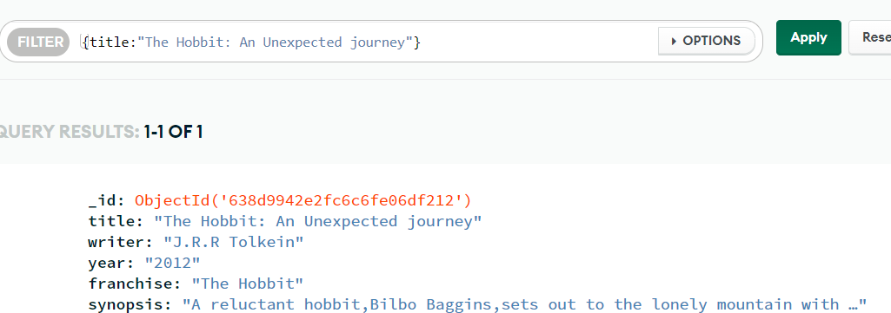

2.ADD synopsis to “the hobbit:the desoulation of smaug”.

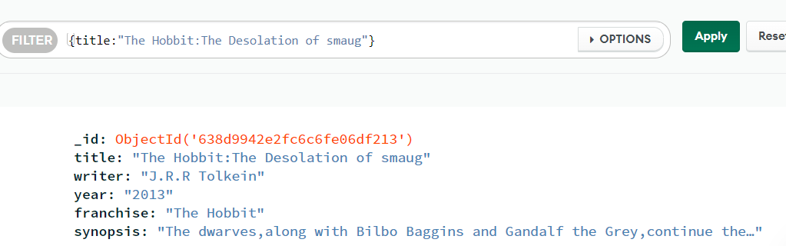

3.Add an actor named “Samuel L.Jackson” to the movie “Pulp Fiction”

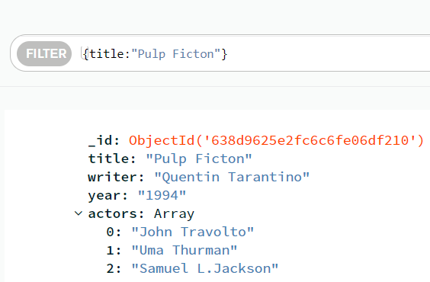

4.Find all the movies that contain synopsis that contains the word “Bilbo”

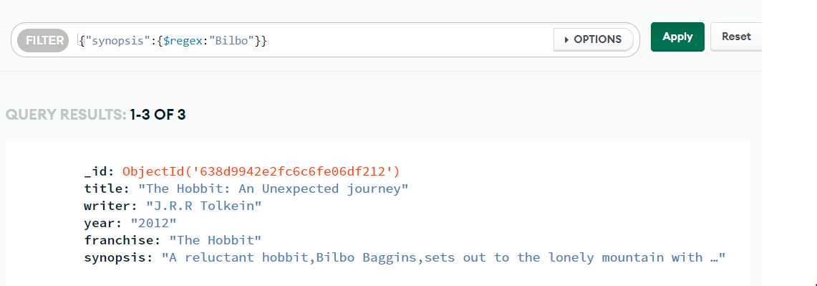

5.Find all the movies synopsis that contains the word “gandalf”

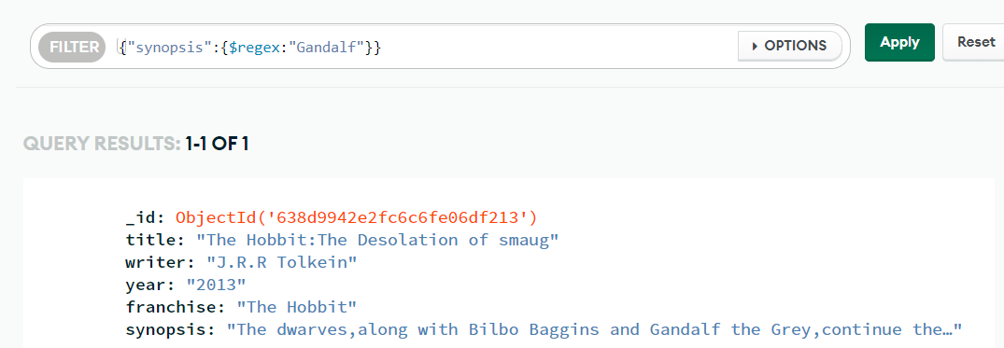

RELATIONSHIPS

1.Find all the users

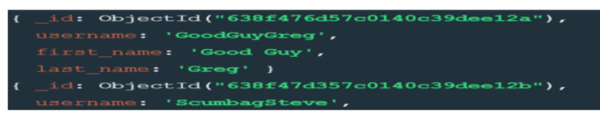

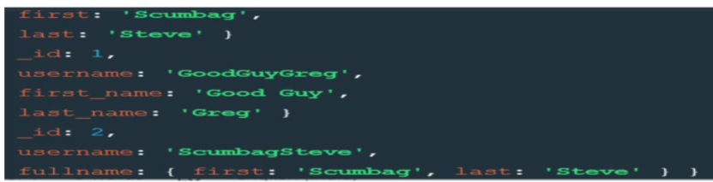

2.Find all the posts

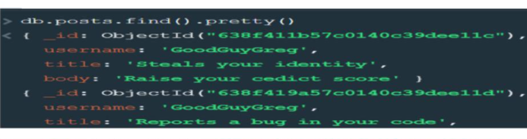

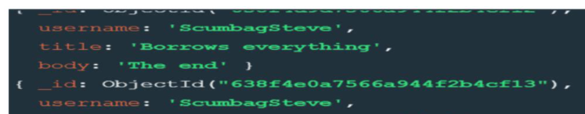

3.find all the post that was author by “GoodGuyGreg”

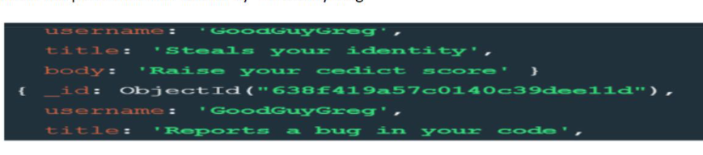

4.find all the post that was author by “ScumbagSteve”

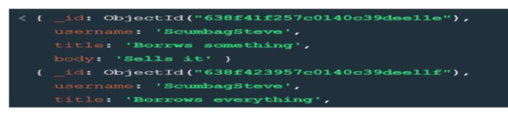

5.find all the comments

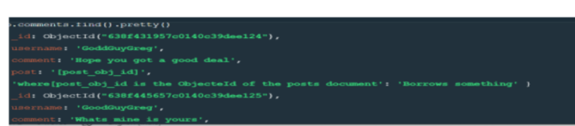

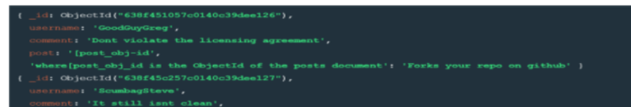

6 .find all the comments that was author by “GoodGuyGreg”

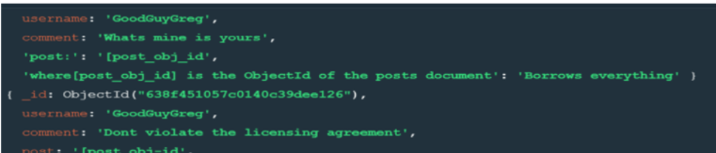

7. .find all the comments that was author by “ScumbagSteve”

